## Title: “Bellabeat Case Study with R”

## Author: Oluwatobi Owamokele

## Date: ‘2022-05-31’

## 

## The Company - Bellabeat



Bellabeat is a high-tech manufacturer of health-focused smart products for women. The stakeholders and founders are Urška Sršen and Sando Mur founded Bellabeat. Sršen used her background as an artist to develop beautifully designed technology that informs and inspires women around the world. Collecting data on activity, sleep, stress, and reproductive health has allowed Bellabeat to empower women with knowledge about their own health and habits. Since it was founded in 2013, Bellabeat has grown rapidly and quickly positioned itself as a tech-driven wellness company for women.

## Questions for analysis

1. What are some trends in smart device usage?
2. How could these trends apply to Bellabeat customers?
3. How could these trends help influence Bellabeat marketing strategy?

## Business Task

Identifying opportunities for growth based on market trends for Bellabeat’s fitness tracker and recommendations to improve marketing strategy in order to thrive better in the market.

## About dataset

Data was got from public dataset- <https://www.kaggle.com/datasets/arashnic/fitbit> (CC0: Public Domain, dataset made available through Mobius): This Kaggle data set contains personal fitness tracker from fitbit users. These Fitbit users consented to the submission of personal tracker data, including minute-level output for physical activity, heart rate, and sleep monitoring. It includes information about daily activity, steps, sleep patterns, intensities of activities, weight ,heart rate that can be used to explore users’ habits.

## Loading packages for analysis

install.packages("tidyverse")

## Installing package into '/cloud/lib/x86_64-pc-linux-gnu-library/4.2'  
## (as 'lib' is unspecified)

install.packages("lubridate")

## Installing package into '/cloud/lib/x86_64-pc-linux-gnu-library/4.2'  
## (as 'lib' is unspecified)

install.packages("tidyr")

## Installing package into '/cloud/lib/x86_64-pc-linux-gnu-library/4.2'  
## (as 'lib' is unspecified)

install.packages("dplyr")

## Installing package into '/cloud/lib/x86_64-pc-linux-gnu-library/4.2'  
## (as 'lib' is unspecified)

install.packages("ggplot2")

## Installing package into '/cloud/lib/x86_64-pc-linux-gnu-library/4.2'  
## (as 'lib' is unspecified)

## Loading packages

library(tidyverse)

## ── Attaching packages ─────────────────────────────────────── tidyverse 1.3.1 ──

## ✔ ggplot2 3.3.6 ✔ purrr 0.3.4  
## ✔ tibble 3.1.7 ✔ dplyr 1.0.9  
## ✔ tidyr 1.2.0 ✔ stringr 1.4.0  
## ✔ readr 2.1.2 ✔ forcats 0.5.1

## ── Conflicts ────────────────────────────────────────── tidyverse_conflicts() ──  
## ✖ dplyr::filter() masks stats::filter()  
## ✖ dplyr::lag() masks stats::lag()

library(lubridate)

##   
## Attaching package: 'lubridate'

## The following objects are masked from 'package:base':  
##   
## date, intersect, setdiff, union

library(tidyr)  
library(dplyr)  
library(ggplot2)

## Import datasets

activity <- read.csv("dailyActivity_merged.csv")  
calories <- read.csv("dailyCalories_merged.csv")  
intensities <- read.csv("dailyIntensities_merged.csv")  
sleep <- read.csv("sleepDay_merged.csv")  
steps <- read.csv("dailySteps_merged.csv")  
weight_log_info <- ("weightLogInfo_merged.csv")

head(activity)

## Id ActivityDate TotalSteps TotalDistance TrackerDistance  
## 1 1503960366 4/12/2016 13162 8.50 8.50  
## 2 1503960366 4/13/2016 10735 6.97 6.97  
## 3 1503960366 4/14/2016 10460 6.74 6.74  
## 4 1503960366 4/15/2016 9762 6.28 6.28  
## 5 1503960366 4/16/2016 12669 8.16 8.16  
## 6 1503960366 4/17/2016 9705 6.48 6.48  
## LoggedActivitiesDistance VeryActiveDistance ModeratelyActiveDistance  
## 1 0 1.88 0.55  
## 2 0 1.57 0.69  
## 3 0 2.44 0.40  
## 4 0 2.14 1.26  
## 5 0 2.71 0.41  
## 6 0 3.19 0.78  
## LightActiveDistance SedentaryActiveDistance VeryActiveMinutes  
## 1 6.06 0 25  
## 2 4.71 0 21  
## 3 3.91 0 30  
## 4 2.83 0 29  
## 5 5.04 0 36  
## 6 2.51 0 38  
## FairlyActiveMinutes LightlyActiveMinutes SedentaryMinutes Calories  
## 1 13 328 728 1985  
## 2 19 217 776 1797  
## 3 11 181 1218 1776  
## 4 34 209 726 1745  
## 5 10 221 773 1863  
## 6 20 164 539 1728

## Data Cleaning

I already noticed the error in date format when I initially loaded the datasets and this error is present in all. Before continuing this analysis, the datatype must be changed correctly to date and datetime.

#### Formatting datasets

activity$ActivityDate <- as.Date(activity$ActivityDate, "%m/%d/%Y")  
activity$date <- format(activity$ActivityDate, format = "%m/%d/%y")  
calories$ActivityDay <- as.Date(calories$ActivityDay , "%m/%d/%Y")  
intensities$ActivityDay <- as.Date(intensities$ActivityDay, "%m/%d/%Y")  
sleep$SleepDay <- as.POSIXct(sleep$SleepDay, format= "%m/%d/%Y %I:%M:%S %p", tz= Sys.timezone())  
sleep$date <- format(sleep$SleepDay, format = "%m/%d/%y")  
steps$ActivityDay <- as.Date(steps$ActivityDay, "%m/%d/%Y")

#### Checking for duplicates

sum(duplicated(activity))

## [1] 0

sum(duplicated(calories))

## [1] 0

sum(duplicated(intensities))

## [1] 0

sum(duplicated(steps))

## [1] 0

sum(duplicated(sleep))

## [1] 3

#### Remove duplicates

sleep <- sleep %>%  
 distinct() %>%  
 drop_na()

#### Confirm duplicates have been removed

sum(duplicated(sleep))

## [1] 0

## Summarizing datasets

# activity  
activity %>%   
 select(TotalSteps,  
 TotalDistance,  
 SedentaryMinutes, Calories) %>%  
 summary()

## TotalSteps TotalDistance SedentaryMinutes Calories   
## Min. : 0 Min. : 0.000 Min. : 0.0 Min. : 0   
## 1st Qu.: 3790 1st Qu.: 2.620 1st Qu.: 729.8 1st Qu.:1828   
## Median : 7406 Median : 5.245 Median :1057.5 Median :2134   
## Mean : 7638 Mean : 5.490 Mean : 991.2 Mean :2304   
## 3rd Qu.:10727 3rd Qu.: 7.713 3rd Qu.:1229.5 3rd Qu.:2793   
## Max. :36019 Max. :28.030 Max. :1440.0 Max. :4900

#calories   
calories %>%  
 select(Calories) %>%  
 summary()

## Calories   
## Min. : 0   
## 1st Qu.:1828   
## Median :2134   
## Mean :2304   
## 3rd Qu.:2793   
## Max. :4900

#sleep  
 sleep %>%  
 select(TotalMinutesAsleep, TotalTimeInBed) %>%  
 summary()

## TotalMinutesAsleep TotalTimeInBed   
## Min. : 58.0 Min. : 61.0   
## 1st Qu.:361.0 1st Qu.:403.8   
## Median :432.5 Median :463.0   
## Mean :419.2 Mean :458.5   
## 3rd Qu.:490.0 3rd Qu.:526.0   
## Max. :796.0 Max. :961.0

## Visualization

ggplot(data=activity, aes(x=TotalSteps, y=Calories)) +   
 geom_point() + geom_smooth() + labs (title="Total Steps vs. Calories")

## `geom_smooth()` using method = 'loess' and formula 'y ~ x'

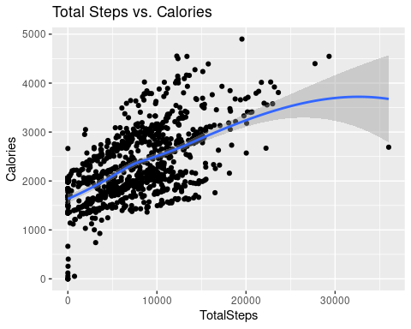

There is visibly a positive correlation between Total steps and Calories which shows us that more steps taken every day will lead to more calories being burned

ggplot(data=sleep, aes(x=TotalMinutesAsleep, y=TotalTimeInBed)) +   
 geom_point()+ labs(title="Total Minutes Asleep vs. Total Time in Bed")

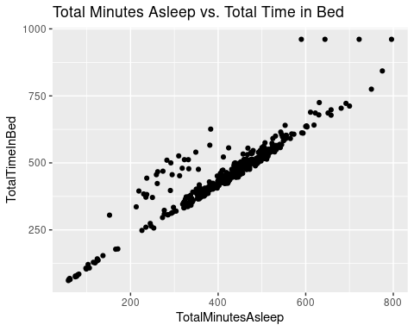

This graphs shows a positive linear correlation. Hence, the more time they spend in bed, the likelihood they fall asleep

#### Grouping users by steps taken

daily_average_steps <- activity %>%  
 group_by(Id) %>%  
 summarise (mean_steps = mean(TotalSteps))  
head(daily_average_steps)

## # A tibble: 6 × 2  
## Id mean_steps  
## <dbl> <dbl>  
## 1 1503960366 12117.  
## 2 1624580081 5744.  
## 3 1644430081 7283.  
## 4 1844505072 2580.  
## 5 1927972279 916.  
## 6 2022484408 11371.

user_group <- daily_average_steps %>%  
 mutate(user_group = case_when(  
 mean_steps < 5000 ~ "sedentary",  
 mean_steps >= 5000 & mean_steps <= 7499 ~ "lightly active",   
 mean_steps >= 7500 & mean_steps <= 9999 ~ "moderately active",   
 mean_steps >= 10000 ~ "very active"  
 ))  
head(user_group)

## # A tibble: 6 × 3  
## Id mean_steps user_group   
## <dbl> <dbl> <chr>   
## 1 1503960366 12117. very active   
## 2 1624580081 5744. lightly active  
## 3 1644430081 7283. lightly active  
## 4 1844505072 2580. sedentary   
## 5 1927972279 916. sedentary   
## 6 2022484408 11371. very active

ggplot(data=user_group)+  
 geom_bar(mapping = aes(user_group, color=user_group))+  
 labs(title="User group")

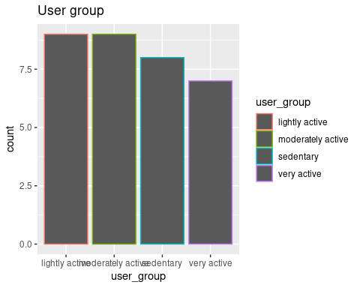

## Conclusion and Recommendation

1. Majority of users are lightyly active and moderately active.
2. Sedentary minutes was approx 991 minutes which is too high for someone aiming for fitness.
3. Many of the users on the average sleep less than six hours which isn’t the best but should attain at least seven hours of sleep or more.
4. There should be a notification to alert users to get moving and monitor their sleep patterns.
5. There should be a monitor to help users keep track of their weight and maintain healthy BMI.
6. Notifications should be put in place to alert user to workout for at least twenty(20) minutes each day and to take water to stay hydrated.
7. In summary,the fitness tracker application needs a bit of revamping by programmers which will help achieve the above goals and help users achieve a more healthy lifestyle and thus stand out in the competitive market.

This is my first project using R. Comments and recommendations are highly appreciated.